C S 501 – Internet of Things

**Assignment-4 Group Members**

|  |  |  |
| --- | --- | --- |
| **Student Name** | **Student Id** | **Student Email ID** |
| Lohitha Yalavarthi | 002289255 | [lyalavarthi20@ubishops.ca](mailto:lyalavarthi20@ubishops.ca) |
| Nitish Kumar Pilla | 002286814 | [npilla20@ubishops.ca](mailto:npilla20@ubishops.ca) |
| Bhargav Movva | 002292699 | [BMOVVA21@ubishops.ca](mailto:BMOVVA21@ubishops.ca) |

1. Click on Cooja Desktop Icon and it opens the cooja: The Contiki Network Simulator

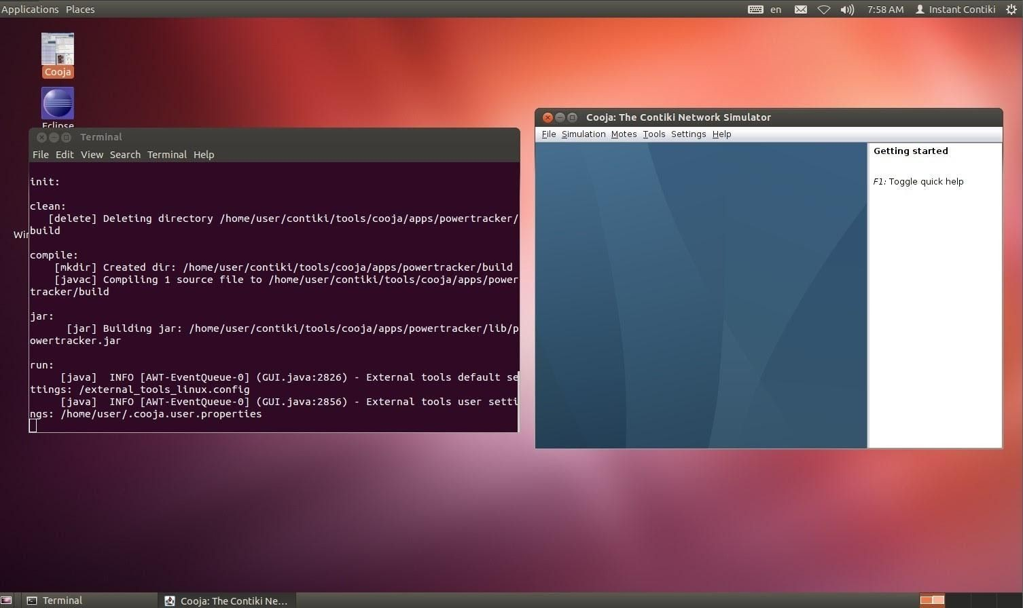

1. Click the new simulation under File menu and it opens the create new simulation dialog and name the simulation as **Ping pong** as shown in the screenshot and a new simulation gets created by clicking on the create button.

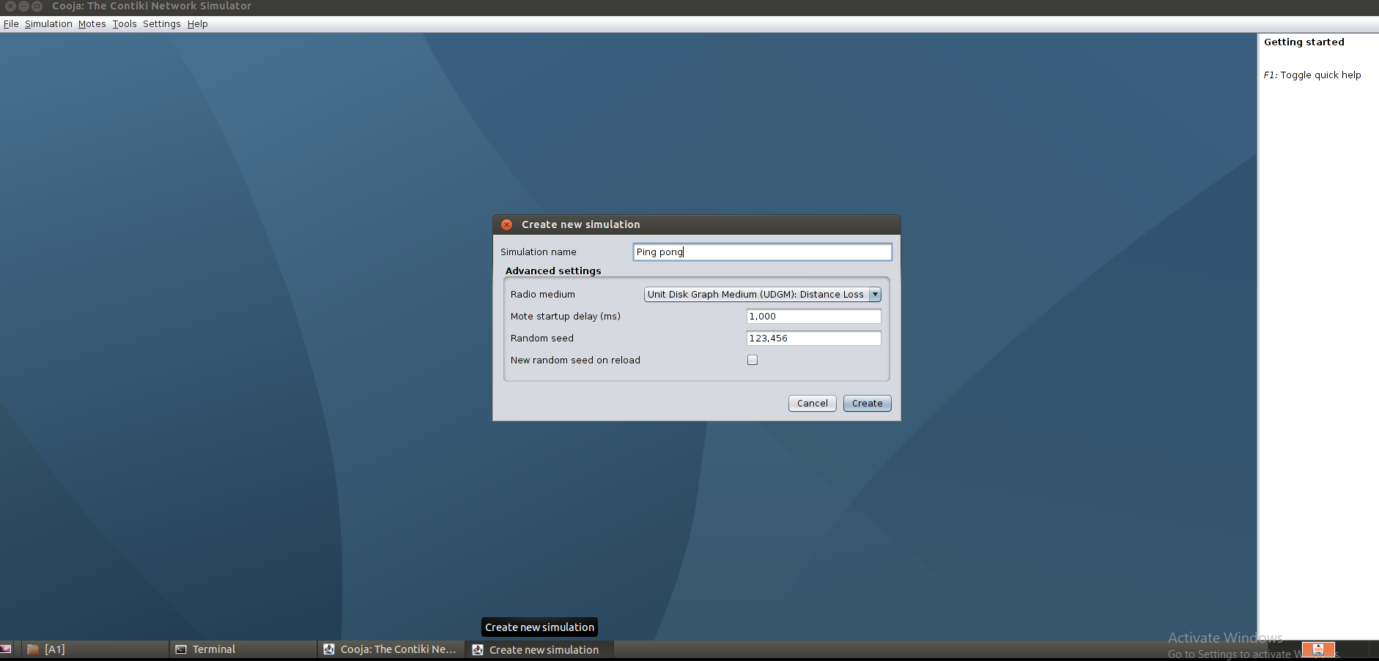

1. It brings up the new simulator window (**Ping Pong-Cooja: The Contiki Network Simulator**) which has Network and motes output and Notes and Timeline and Simulation control windows.

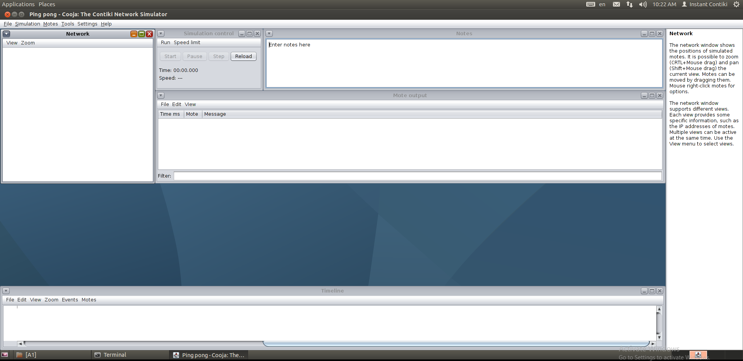

1. Click on Motes option in the simulator menu and select Add Motes->Create new moto type-> Sky mote to create sky mote type.

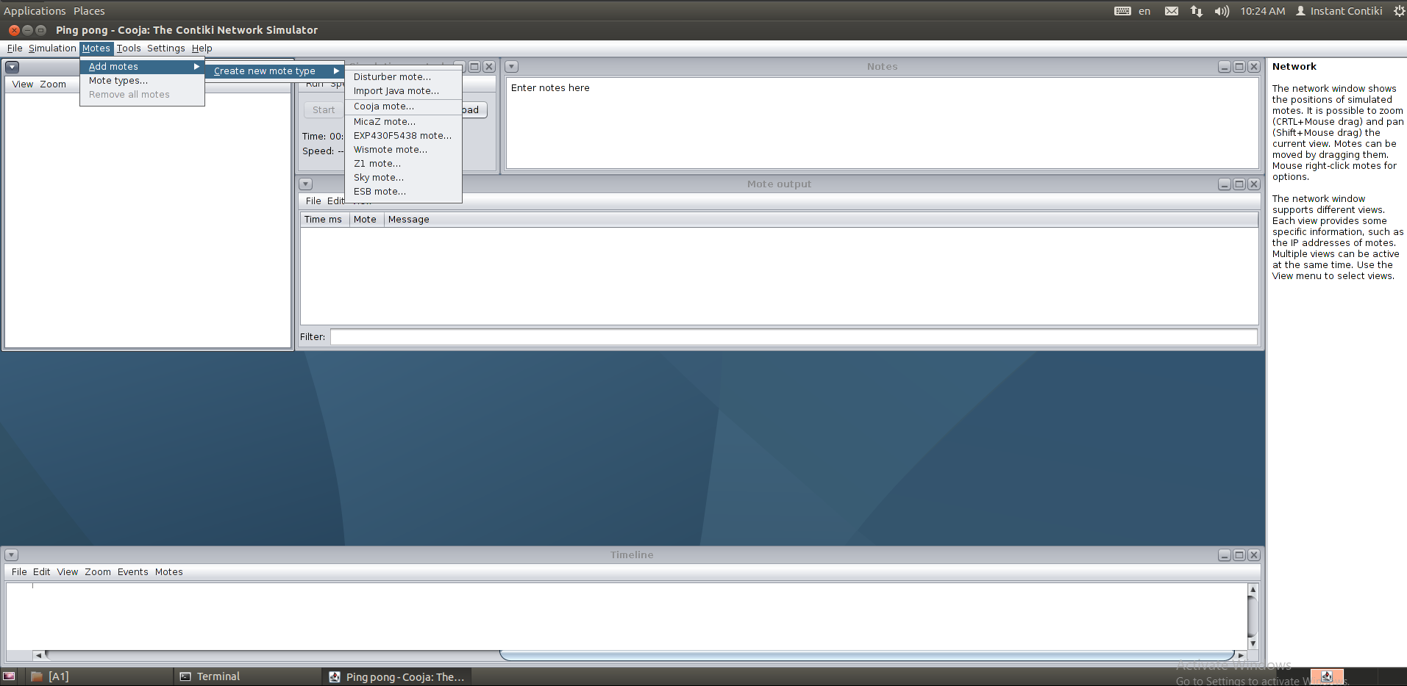

1. After selecting the above options opens **Create Mote Type : Compile Contiki for sky** dailog where Description name and Contiki process/Firmware is given.

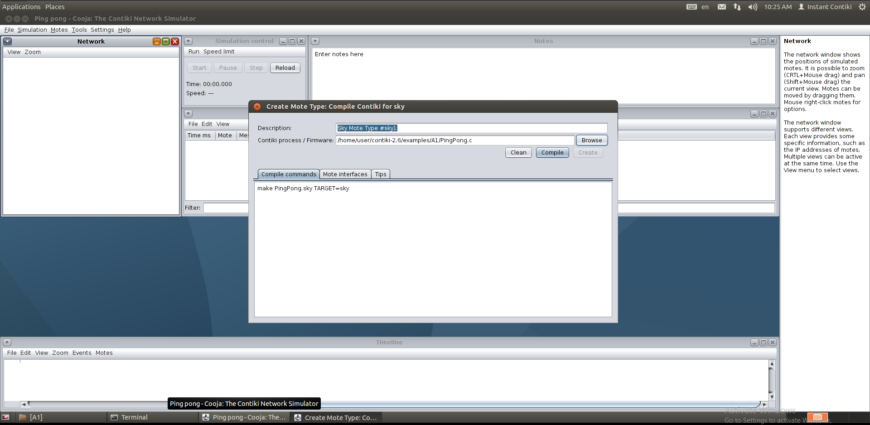

1. Click the compile button and the compilation results shows in the compilation output tab.

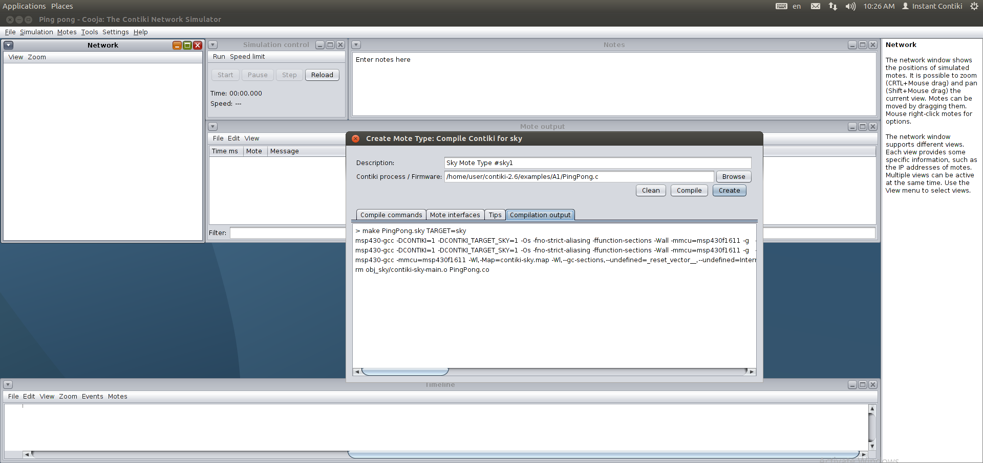

1. After successful compilation, clicking on the create button opens a dialog to enter the no of motes. no of motes entered here are 2 as shown in the screenshot.

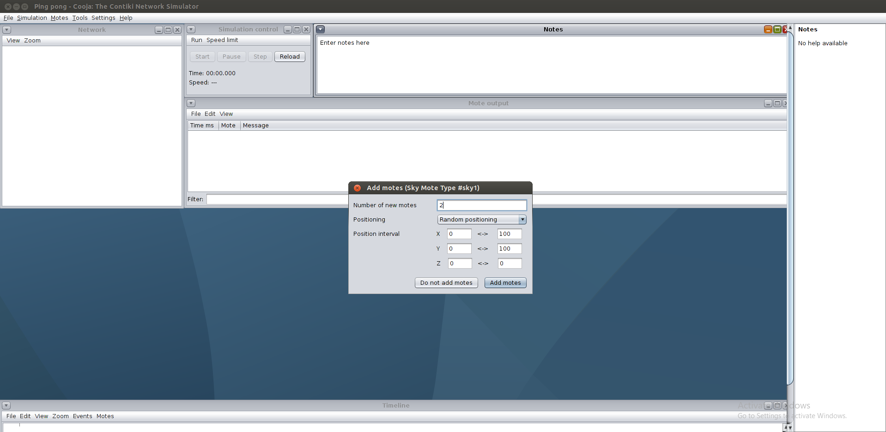

1. Click the start button in the simulation control window to start the simulation and the compilation results are seen in the mote output and the timeline window.

Here we have added up to 2 motes only and we can observe that pong response is being sent from nodes.

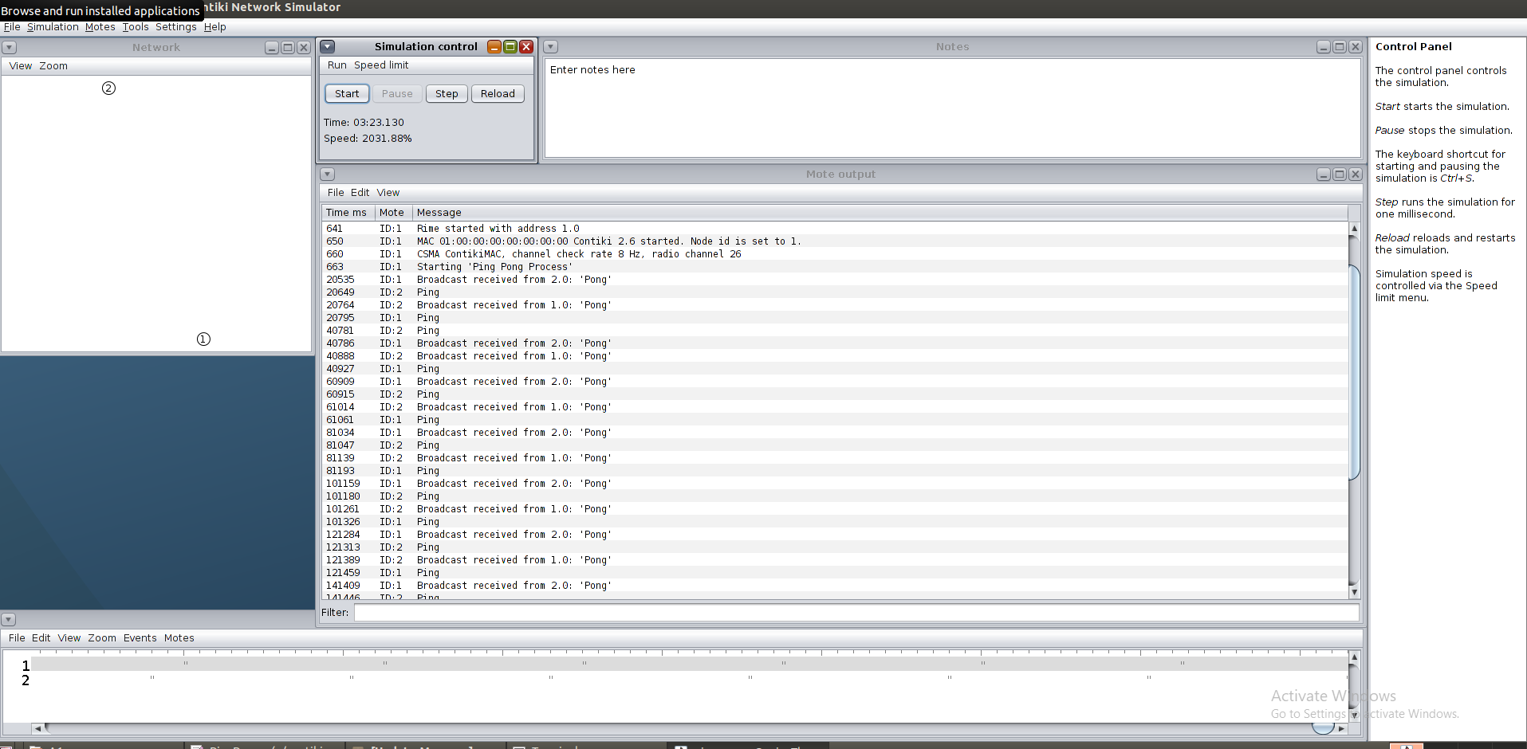

1. Now we will add another 4 motes and reload the simulation.

By adding extra motes, we can clearly see that the pong response is received only from some nodes. From remaining nodes there is no response

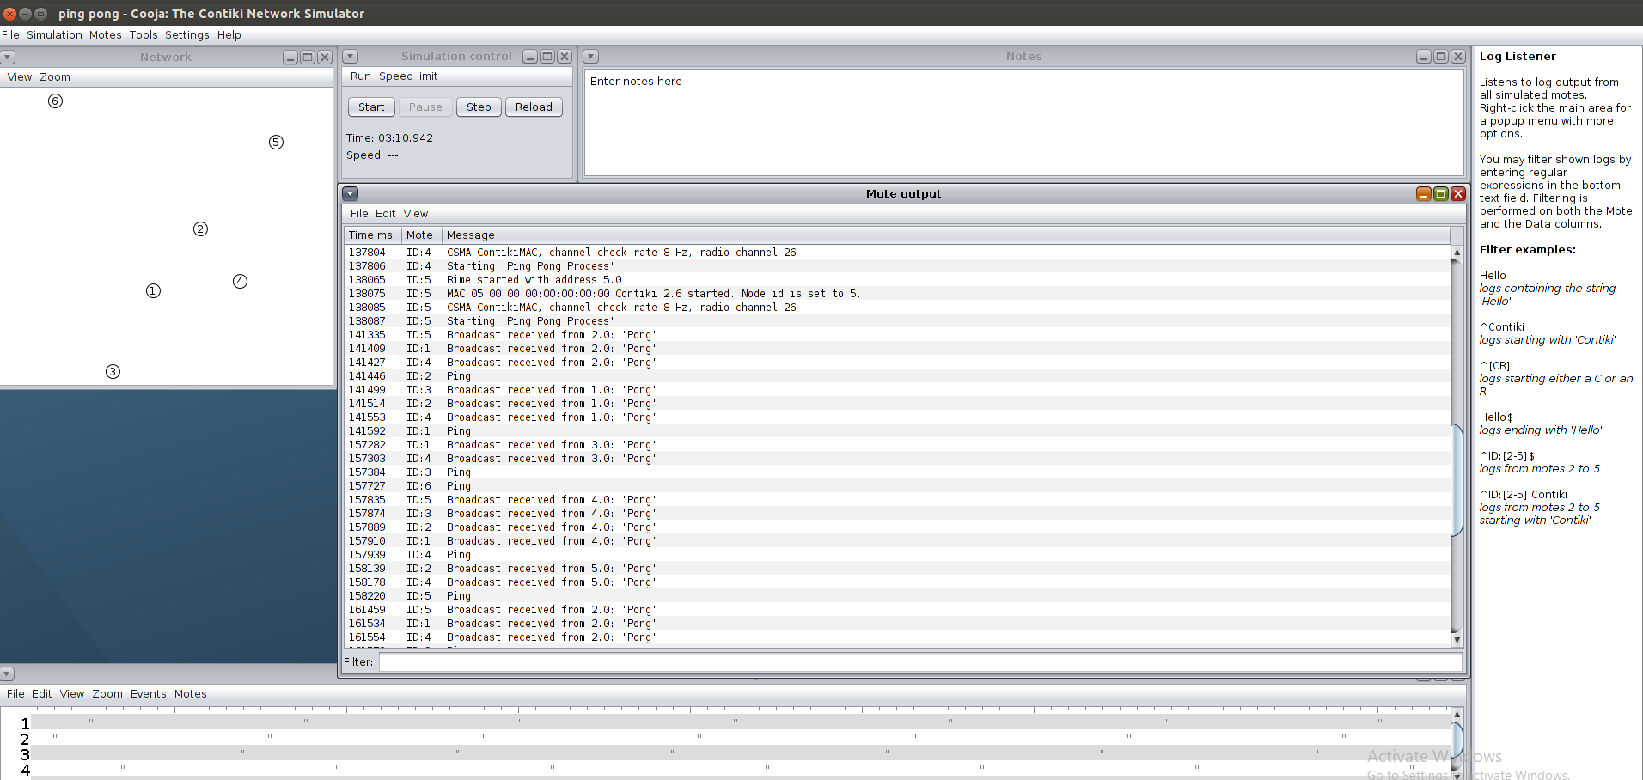

**The broadcast protocol is inefficient because:**

**A)**

From the above simulations, we can clearly see that adding a greater number of motes in broadcast protocol caused some irregular responses or some nodes are not receiving proper responses to pings.

This might be the reason for broadcast protocol being inefficient.

It is also inefficient because a lot of bandwidth is being wasted in the broadcast protocol.

**How could the protocol be made more efficient?**

**A)**

We can place time delay before receiving pong response from nodes to make it more efficient.

If we add more nodes in the network, and the nodes in the network(left side) are dispersed far away from each other ,Then the nodes that are located far away from other nodes are not responding with other nodes and not broadcasting properly.

For that we have to make the nodes in the network close to each other (i.e changing the positions of nodes close to each other).Then the broadcasting of each node is being executed properly.

Here the motes in the network are placed close to each other. Hence we can see that broadcast is received for all nodes correctly.

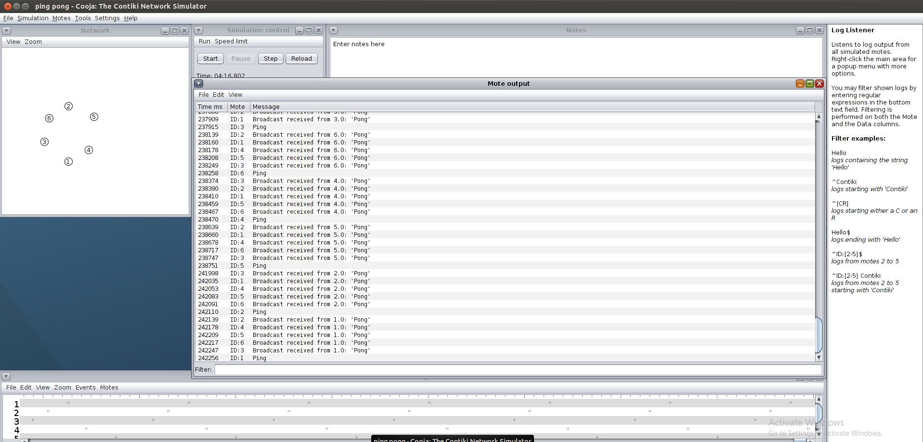

==========================**The End**==========================